Test for Carbohydrates
- Test For Glucose
  - Benedict's Test

Materials Required:
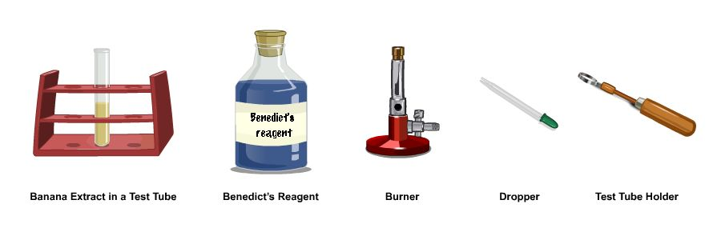

Procedure:
- Using a dropper, take a small quantity of Benedict’s reagent.
- Add the reagent to the test tube containing banana extract.
- Boil the sample over a burner for 2 minutes holding the test tube firmly with a test tube holder.
- Keep shaking the test tube as it is being heated.
- A brick red precipitate appears, indicating the presence of glucose in the banana extract.

Conclusion:
On boiling banana extract with the Benedict’s reagent, the cupric ion present in the Benedict’s reagent is reduced by the reducing agent, sugar, to form a brick red coloured precipitate of cuprous oxide.
- Fehling's Test

Materials Required:
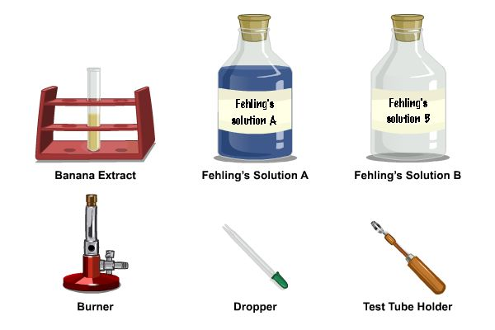

Procedure:
- Using a dropper, take a small quantity of Fehling’s solution A.
- Add the Fehling’s solution A to the test tube containing banana extract.
- Using a dropper, take a small quantity of Fehling’s solution B.
- Add Fehling’s solution B to the test tube containing banana extract.
- Boil the sample over a burner for 2 minutes, holding the test tube firmly with a test tube holder.
- Keep shaking the test tube while heating.
- A brick red precipitate appears, indicating the presence of glucose in the banana extract.

Conclusion:
The cupric ion present in the Fehling’s solution is reduced on boiling by the reducing substance, sugar, to form the brick red coloured precipitate of cuprous oxide.
- Test for Sucrose

Materials Required:
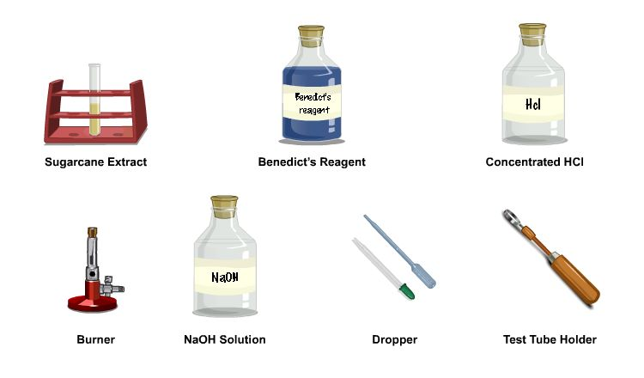

Procedure:
- Using a dropper, take a small quantity of concentrated HCl.
- Add 2 to 3 drops of concentrated HCl to the test tube containing sugarcane extract.
- Boil the sample over a burner for 2 minutes, holding the test tube firmly with a test tube holder.
- This hydrolyses sucrose into glucose and fructose.
- Using a dropper, take a small quantity of NaOH solution.
- Add few drops of NaOH solution to the test tube to make the solution alkaline.
- Now we can perform Benedict’s test to this solution to test for the presence of glucose.
- Using a dropper, take a small quantity of Benedict’s reagent.
- Add the reagent to the test tube containing the sample.
- Boil the sample over a burner for 2 minutes, holding the test tube firmly with a test tube holder.
- The colour changes from blue to green and finally to orange or brick red, indicating the presence of glucose.
- Test for Starch

Materials Required
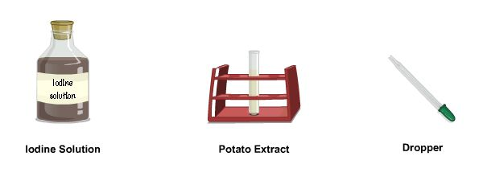

Procedure
- Using a dropper, take a small quantity of iodine solution.
- Add 5 drops of iodine solution to the test tube containing potato extract.
- Blue black colour indicates the presence of starch in potato extract.

Test for Proteins
- Biuret Test

Materials Required
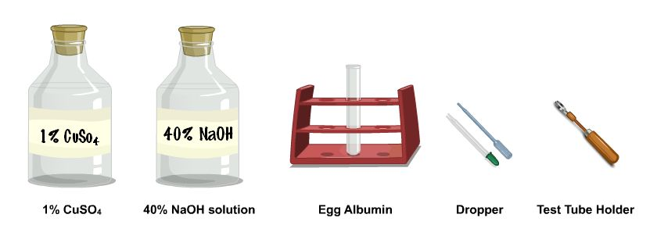

Procedure
- Using a dropper, take a small quantity of 40% NaOH solution.
- Add a few drops of NaOH solution to the test tube containing egg albumin.
- Using a dropper, take a small quantity of 1% CuSO4 solution.
- Add 2-3 drops of CuSO4 solution to the test tube containing egg albumin.
- Shake the solution to mix it well.
- A violet colour appears in the test tube, which indicates the presence of proteins.
- Xanthoproteic Test

Materials required
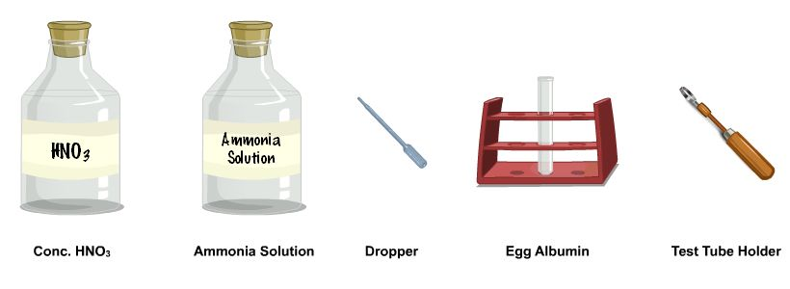

Procedure
- Using a dropper, take a small quantity of concentrated HNO3.
- Add 5 drops of Concentrated HNO3 to the test tube containing egg albumin.
- Boil the sample over a burner for 2 minutes, holding the test tube firmly with a test tube holder. Yellow precipitate appears in the test tube.
- Using a dropper, take a small quantity of ammonia solution.
- Add a few drops of ammonia solution to the sample.
- Shake the solution to mix it well.
- Yellow ppt. changes to orange in colour, which indicates the presence of protein.
- Million’s Test

Materials Required
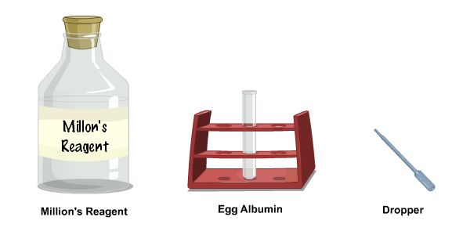

Procedure
- Using a dropper, take a small quantity of Million's regent.
- Add few drops of Million's reagent to the test tube containing egg albumin.
- Wait for some time.
- Pink colour appears in the test tube, which indicates the presence of protein.

Test for Fats
- Sudan III Test

Materials Required:
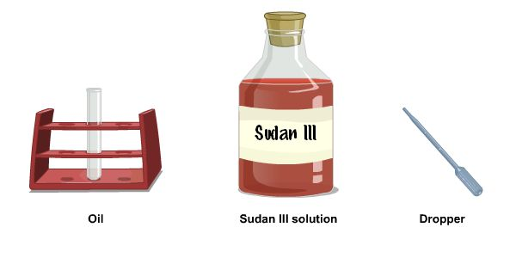

Procedure:
- Using a dropper, take a small quantity of Sudan III reagent.
- Add few drops of Sudan III reagent to the test tube containing egg albumin.
- Shake the solution to mix it well.
- Pink droplets appear indicating the presence of fat in the sample.
- Paper Spot Test

Materials Required:
Peanut seeds and piece of white paper.

Procedure:
- Take a peanut seed from the watch glass.
- Crush the peanut seed and rub it on a piece of white paper.
- Paper becomes translucent at the spot, which indicates the presence of fat.

Simulator Procedure (as performed through the Online Labs)
You can select the type of test from the ‘Select the food substance’ drop down list.

Carbohydrates
You can select the type of test from the ‘Select the carbohydrate’ drop down list.
- Glucose
You can select the type of test from the ‘Select the Test” drop down list.
- Benedict’s Test
- Click and drag the dropper from the Benedict’s reagent bottle and move it into the test tube containing banana extract to drop the Benedict’s reagent into it.
- Drag the test tube towards the beaker to place it in the water bath.
- Click on the switch of the hot plate to turn it on.
- Click on the inference icon to see the inference.
- Fehling’s Test
- Click and drag the dropper from Fehling’s solution A and move it into the test tube containing banana extract to drop the Fehling’s solution A into it.
- Click and drag the dropper from the Fehling’s solution B bottle and move it into the test tube containing banana extract to drop the Fehling’s solution B into it.
- Drag the test tube towards the beaker to place in the water bath.
- Click on the switch of the hot plate to turn it on.
- Click on the inference icon to see the inference.
- Sucrose
  - Benedict’s Test
- Click and drag the dropper from the concentrated HCl bottle and move it into the test tube containing sugarcane extract to drop the HCl into it.
- Click on the knob of the burner to turn it on.
- Drag the test tube towards the burner to heat it.
- Click on the inference icon to see the inference.
- Click and drag the dropper from the NaOH solution bottle and move it into the test tube containing sugarcane extract to drop the NaOH into it.
- Drag the dropper towards test tube B to drop NaOH slowly along the side of the test tube.
- Click on the next button to continue.
- Click and drag the dropper from the Benedict’s reagent bottle and move it into the test tube to drop Benedict’s reagent into it.
- Drag the test tube towards the beaker to place in the water bath.
- Click on the switch of the hot plate to turn it on.
- Click on the inference icon to see the inference.
- Fehling’s Test
- Click and drag the dropper from the concentrated HCl bottle and move it into the test tube containing sugarcane extract to drop the HCl into it.
- Click on the knob of the burner to turn it on.
- Drag the test tube towards the burner to heat it.
- Click on the inference icon to see the inference.
- Click and drag the dropper from the NaOH solution bottle and move it into the test tube containing sugarcane extract to drop the NaOH into it.
- Click on the next button to continue.
- Click and drag the dropper from Fehling’s solution A and move it into the test tube to drop the Fehling’s solution A into it.
- Click and drag the dropper from the Fehling’s solution B bottle and move it into the test tube to drop Fehling’s solution B into it.
- Drag the test tube towards the beaker to place in the water bath.
- Click on the switch of the hot plate to turn it on.
- Click on the inference icon to see the inference.
- Starch
  - Iodine Test
- Click and drag the dropper from the Iodine bottle and move it into the test tube containing potato extract to drop the Iodine solution into it.
- Click on the inference icon to see the inference.
- Benedict’s Test
- Click and drag the dropper from the concentrated HCl bottle and move it into the test tube containing potato extract to drop the HCl into it.
- Click on the knob of the burner to turn it on.
- Drag the test tube towards the burner to heat it.
- Click on the inference icon to see the inference.
- Click and drag the dropper from the NaOH solution bottle and move it into the test tube to drop the NaOH into it.
- Click on the next button to continue.
- Click and drag the dropper from the Benedict’s reagent bottle and move it into the test tube to drop the Benedict’s reagent into it.
- Drag the test tube towards the beaker to place in the water bath.
- Click on the switch of the hot plate to turn it on.
- Click on the inference icon to see the inference.
- Fehling’s Test
- Click and drag the dropper from the concentrated HCl bottle and move it into the test tube containing potato extract to drop the HCl into it.
- Click on the knob of the burner to turn it on.
- Drag the test tube towards the burner to heat it.
- Click on the inference icon to see the inference.
- Click and drag the dropper from the NaOH solution bottle and move it into the test tube to drop the NaOH into it.
- Click on the next button to continue.
- Click and drag the dropper from Fehling’s solution A and move it into the test tube to drop Fehling’s solution A into it.
- Click and drag the dropper from the Fehling’s solution B bottle and move it into the test tube to drop Fehling’s solution B into it.
- Drag the test tube towards the beaker to place in the water bath.
- Click on the switch of the hot plate to turn it on.
- Click on the inference icon to see the inference.

Proteins
- Biuret Test
- Click and drag the dropper from the NaOH solution bottle and move it into the test tube containing egg albumin to drop the NaOH into it.
- Click and drag the dropper from the CuSO4 solution bottle and move it into the test tube containing egg albumin to drop the CuSO4 into it.
- Click on the inference icon to see the inference.
- Xanthoproteic Test
- Click and drag the dropper from the concentrated HNO3 solution bottle and move it into the test tube containing egg albumin to drop the HNO3 into it.
- Click on the knob of the burner to turn it on.
- Drag the test tube towards the burner to heat it.
- Click and drag the dropper from the NH4OH solution bottle and move it into the test tube containing egg albumin to drop the NH4OH into it.
- Click on the inference icon to see the inference.
- Million’s Test
- Click and drag the dropper from the concentrated Million’s reagent bottle and move it into the test tube containing egg albumin to drop the Million’s reagent into it.
- Click on the inference icon to see the inference.

Fats
- Sudan III Test
- Click and drag the dropper from the concentrated Sudan III reagent bottle and move it into the test tube containing coconut oil to drop the Sudan III reagent into it.
- Click on the inference icon to see the inference.

